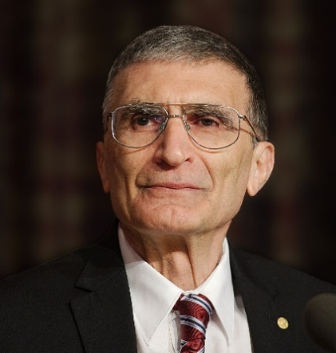
Prof. Dr. Aziz Sancar was born on September 8, 1946, in the Savur district of Mardin.He completed his primary and secondary education in Mardin. In 1963, he was admitted to the Faculty of Medicine at Istanbul University and graduated at the top of his class in 1969. After graduation, he returned to his hometown of Savur, where he worked as a doctor at the local health clinic for two years. He then received a NATO-TÜBİTAK scholarship and began conducting research at Johns Hopkins University, one of the most prestigious educational institutions in the United States. However, due to adaptation issues, he returned to Turkey after a short time.
His passion for science persisted, and he returned to the United States to pursue a master's and Ph.D. in molecular biology at the University of Texas at Dallas. There, together with his advisor Prof. Claud Rupert, Sancar studied the DNA-repairing enzyme called photolyase and discovered a crucial mechanism responsible for repairing damaged DNA. This research played a significant role in completing both his master's and doctoral studies.
Between 1977 and 1982, he worked at Yale University School of Medicine, conducting significant research on DNA repair. He also completed his associate professorship thesis during this time.
Since 1997, Prof. Dr. Aziz Sancar has continued his research at the Department of Biochemistry and Biophysics at the University of North Carolina in the United States. He has made groundbreaking contributions in the fields of DNA repair, cell cycle, biological clock, and cancer treatment. He has published over 415 scientific articles and 33 books, greatly contributing to the scientific world.
In 2015, he was awarded the Nobel Prize in Chemistry, along with American scientist Paul Modrich and Swedish scientist Tomas Lindahl, for their pioneering work on DNA repair. This award recognized the outcome of over 30 years of independent research into how DNA repairs itself and how genetic information is preserved. With this award, Aziz Sancar became the second Turkish person to receive a Nobel Prize and the first Turkish citizen to receive one in the field of science.
A U.S. citizen, Sancar is married to Biochemistry Professor Gwen Boles Sancar. Together, they founded the Aziz & Gwen Sancar Foundation to support Turkish students and strengthen Turkish-American relations. This foundation established the "Carolina Turkish House" (Carolina Türk Evi) in North Carolina as a student guesthouse, providing educational support for young scientists.
Prof. Dr. Aziz Sancar has received numerous prestigious awards and memberships both in Turkey and internationally. Some of his most notable honors include:
- 1984 – U.S. National Science Foundation Young Investigator Award
- 1990 – American Society for Photobiology Award
- 1995 – U.S. National Institutes of Health Award
- 1997 – TÜBİTAK Science Award
- 2004 – American Academy of Arts and Sciences Award
- 2005 – Membership in the U.S. National Academy of Sciences (first Turkish scientist)
- 2006 – Full Membership in the Turkish Academy of Sciences
- 2007 – Vehbi Koç Award
- 2015 – Nobel Prize in Chemistry

